An advisory commission of the Coastal Protection and Restoration Authority
cOASTAL LOUISIANA LEVEE CONSORTIUM

Amite River Basin Drainage and Water Conservation District

Atchafalaya Basin Levee District

Office of the Governor-Coastal Activities

Chenier Plain Coastal Restoration & Protection Authority

Grand Isle Independent Levee District

Iberia Parish Levee District

Jefferson Davis Parish Government

Lafitte Area Independent Levee District

Lafourche Basin Levee District

Non-Flood Protection Asset Management Authority

North Lafourche Conservation, Levee and Drainage District

Plaquemines Parish Government

Pontchartrain Levee District

The Sewerage and Water Board of New Orleans

South Lafourche Levee District

Southeast Louisiana Flood Protection Authority—East

Southeast Louisiana Flood Protection Authority—West

St. Mary Levee District

St. Tammany Levee District

Terrebonne Levee and Conservation District

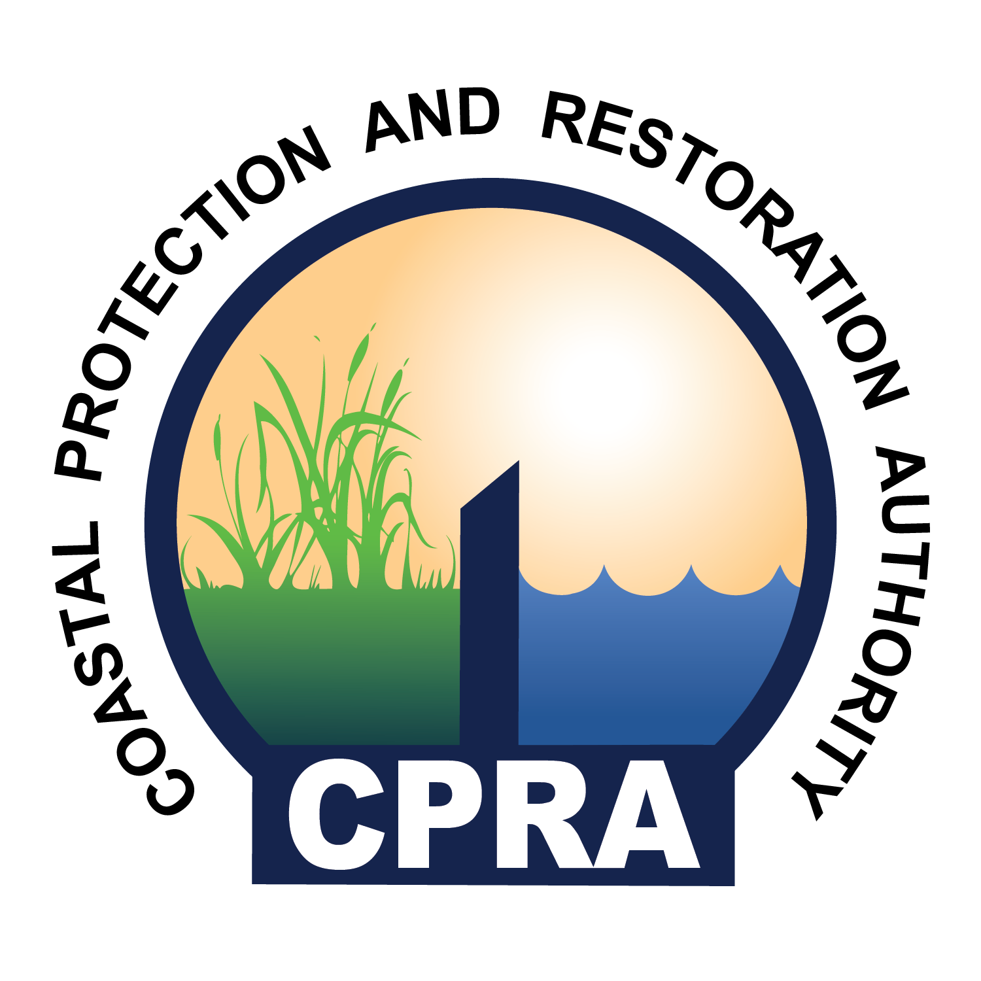

900 North Third St. 4th Floor
Baton Rouge, LA 70802
Levee Consortium Meeting
Emergency Operations Center
Southeast Louisiana Flood Protection Authority – West
7001 River Road, Marrero, LA 70072

Thursday, July 23, 2015
1:00 P.M.

- Call to Order – Windell Curole
- Roll Call
- Approval of Agenda
- Approval of Minutes
- USACE Southwest Coastal Study from the Chenier Plain Authority – Nedra Davis
- 2005 Hurricane Review
- BP Oil Spill Agreement
- New Committee on Shared Investment
- Committee Reports – Committee Chairs
  - Restoration
    - Diversion
    - Marsh Creation
    - Dredged Sediments
  - Legal - Legislation
  - Flood Insurance
  - Levee Standards
  - Mitigation
  - Hazmat and Emergency Preparedness
  - Evacuation
  - Economics
  - Navigation
- Public Comment
- Adjourn

